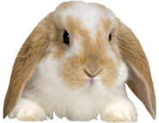
Beaufort County 4-H Rabbit Show Registration
Sunday, June 25 2:00 PM
2017 Sunflower Festival
Raised In a Barn Farm, Chocowinity, NC
Registration Due Friday, June 15

Name:____________________________________________________

Age as of January 1, 2017:_____________________________________

Birthdate:__________________________________________________

Address:___________________________________________________

Parent Name:_______________________________________________

Phone Number:_____________________________________________

Description of Your Rabbit: ________________________________________________________________________________________________________________________________________________________________________________________________________________________________________

Erin Massie, 4-H Agent
Beaufort County Cooperative Extension

